SNapp - Simplified Notation for Sheet Music app

Introduction
My vision is that all musicians be able to have their sheet music customized to their personal needs and preferences. In particular for new students of music, this includes a simplified notation that is easier to learn than traditional notation. I propose that the simplified notation be based on a design that I call What You See Is What You Play, or WYSIWYP. The design is described in the document "WYSYIWYP Simplified Notation for Sheet Music".
But wait, wouldn't a new notation system require that the vast inventory of traditional sheet music to be converted and re-published? To avoid this overwhelming hurdle, conversion to a new system will require a modern "screen" app (computer or handheld device application) to convert traditional sheet music to this simplified format. The app could also provide a vast array of personal customization options. Herein describes an app to do all of this and is named the Simplified Notation for Sheet Music app, or SNapp.
For the foreseeable future, professional and "serious" musicians will certainly want to remain with traditional notation as it is today’s universal standard. However, if an app makes it possible to easily play what is seen then perhaps someday many more musicians may benefit from a new simplified system.
Design Goals
The overarching design goal for this new application is to display notation in a more logical and intuitive fashion as described in the WYSIWYP document. This includes redesigning the staves and notes as well as eliminating key and time signatures. This in turn supports a broader concept of Personalized Sheet Music (PSM) wherein each musician has many control options for displaying sheet music in a customized format that makes reading music as easy as possible.

Conditions for Success
If the design is successful, beginners will spend less time learning how to read music and more time playing it. Before that can happen, without instructors or instruction materials, simplified notation will have to catch on in “bottom up” or grass roots fashion via the app in the same way that memes spread on social media. Perhaps those who gave up playing music because they just couldn’t learn to read it will find that the app works well for them and their resultant web testimonials will inspire other wannabee musicians to try it. And eventually from these roots may sprout the future instructors that will put simplified notation into the musical mainstream.

Features of SNapp

Input and output
The application accepts as input the traditional music notation in a standard format (e.g., MIDI file, MuxicXML), reformats it to the WYSIWYP notation, and displays it on a device's screen. In addition, a musician will be able to input a new composition directly into the application. The musician will have options for display such as adjusting the horizontal and vertical spacing. Printed sheet music could also be created by devices that support printing.

Customization
Rather than a fixed standard like traditional notation, the display of octaves, staves, and notes can be greatly customized to the needs and tastes of the musician. Thus, even though the previously mentioned WYSIWYP document assigns a "default" set of options, the musician is able to customize them as described below.
Octaves. WYSIWYP solves one of main issues with traditional notation wherein degrees of an octave may fall on a line or a space depending on which octave within the staff or across staves. Each octave will be identical allowing beginners to quickly learn how to find a given degree across all octaves and all staves. For example, while the default lines defaults are red on C and Blue on F, these could be changed: different degrees could be selected for lines, or different line types (solid, dashed, etc.) and color could be specified.
Staves. With WYSIWYP, staves are created by stacking up octaves and partial octaves. The musician could define as many (or as few) staves as desired. And for each staff, the following customizations could be made:
- The range of notes in a staff could be fixed by specifying the low and high notes.
- Alternatively, the range could be flexible according to the work itself so the staff would be adjusted to include the lowest and highest note in the work.
Notes (noteheads and duration). The WYSISYP default notehead shapes are solid black circles and triangles (pointing up or down). Alternate noteheads and their colors could be defined by the musician as well as alternate colors for the "stripes" that define the note duration. There would also be the ability to specify that only sharps are to be displayed or only flats.
Other notation. WYSIWYP does not replace all traditional notation elements such as slurs and dynamics. These would be displayed in the same way as traditional notation. However, some notations such as clefs could be customized.
Saving customization preferences. Preferences could be saved in data files at three levels (at least): global, group, and work. Global preferences would include values for all custom options. A musician would use this to set options that are to always to be applied no matter what the work. Group preferences would include a subset of all options that would be applied on top of global preferences. For example, a musician could use these to define preferences to be applied by musical genre. Work preferences are a subset of options that would be applied on top of the global and group preferences. This would allow customization of individual works of music. The work preference file would logically link to the corresponding input file (e.g., MIDI or MusicXML file) by file name. All preference files could be shared with other musicians by sharing the preference files.
Device support. The app should run on all Android, Windows, macOS, and IOS devices such as tablets, smart phones, and PCs.

Playing music with the app
The app's screen device replaces the traditional notation paper sheet music on the music stand. In this section are presented a wide variety of possibilities that could be built into the app that are not available with paper sheet music.
In preparation for playing a selected work, the musician specifies the work's digital input file name as well as which preference files to apply (global, group, and work). And to prepare the musician, the app could provide various analytics of the work such as the following:
- The key signature by name, e.g., C Major. (WYSIWYP notation does not display the traditional key signature marks at the beginning of a staff line).
- The key of the work as analyzed by the app based on note usage in the work (e.g., frequently used starting and ending notes of a passage, repetitions, loudness, etc.).
- Distribution of all notes on the chromatic scale for each staff.
Perhaps for keyboard musicians, the app could also suggest keyboard fingering (numbers 1 to 5) on the left and right hand staff notes. These could be adjusted and saved in the work preference file.
If desired, the musician could turn on a metronome at any speed. This could be an audio and/ or visually by highlighting the notes in the current beat.
The app could also dynamically scroll the staves up and down as needed to fit the screen in order to accommodate the full range of notes in the work.
The app could play the input music so a musician could learn how it is supposed to sound.
The app could "listen" to what's being played and be the automatic "page turner" by scrolling the display. It could respond to verbal commands such as pause, stop, start, speed up/down (the metronome). Perhaps even more advanced commands such as "change key" could be possible.
The app could listen, record errors, and "grade" the musician's playing. (Perhaps much to the chagrin of students with demanding parents and music teachers.)
There could be a variety of preferences for spacing on the virtually displayed page horizontally and vertically to accommodate the tempo and user's eyesight and preferences.

Using SNapp to learn traditional notation
WYSIWYP was designed for beginners who have no aspirations to become professional musicians. However, it was also designed with the realization (and hope) that once learning to play and love music a student may indeed decide subsequently to become more "serious" and to learn traditional notation. This could be achieved by walking away from WYSIWYP and starting to learn to read traditional sheet music cold turkey. However, with the proposed SNapp, a student could opt to transition from WYSIWYP to traditional notation in a step by step fashion. And this is possible because WYSIWYP maintains some of the basic constructs of traditional notation such a horizontal time axis, diatonic staves, and explicit sharps and flats.
Starting with WYSIWYP, the transition steps are summarized as follows by having the app provide a hybrid of notational systems:
Step 1 Convert the WYSIWYP notes to traditional.
Initially, convert the WYSIWYP noteheads to a hybrid of the two systems. As with traditional notation noteheads, the WYSIWYP round and triangular noteheads would be either "hollow" black (for whole and half notes) or solid black for all other durations. Attached to the noteheads would be the traditional stems and flags. The noteheads would be placed in the same horizontal (timeline) positions as WYSIWYP. Notes that are tied in the traditional notation and disappeared in WYSIWYP return to the staff. All the other auxiliary notations will be included such as ties and dots, but not explicit accidental notation since that information is built into the notehead. The following figure demonstrates how this would look. In this very simple example, there are three sharps, one tie, and two dots that extend the note duration. The stripes remain for reference and to help in learning the wide variety of note and rest duration symbols.
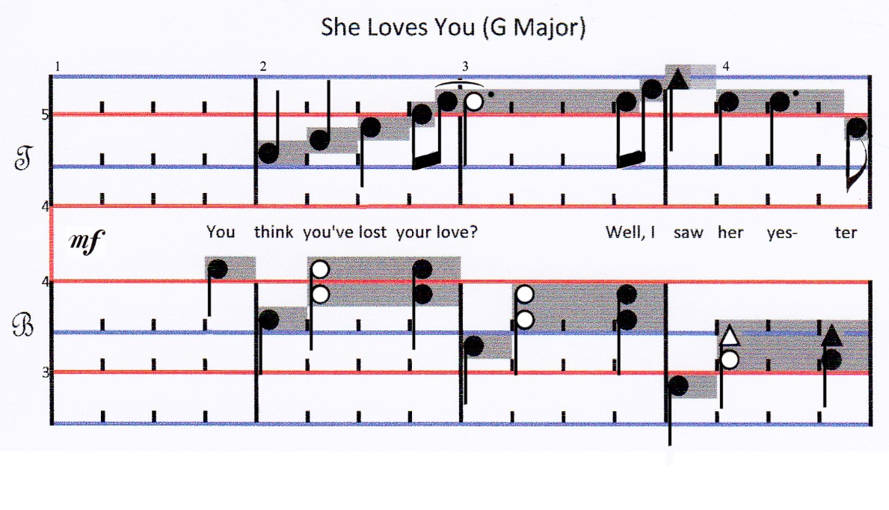
Step 1 initial – WYSIWYP with hybrid notes
The app download package could include a music file that demonstrates notes of different durations (thus a student could see and learn that more flags means less duration!). Examples of other notation that affect note duration could also be included (ties, dots, etc.).
Next, allow the musician to fade away the note duration stripes and the hash marks and return noteheads to their traditional locations and oval shape as shown in the following figure. Without the hash marks for beats, the time signature must return.
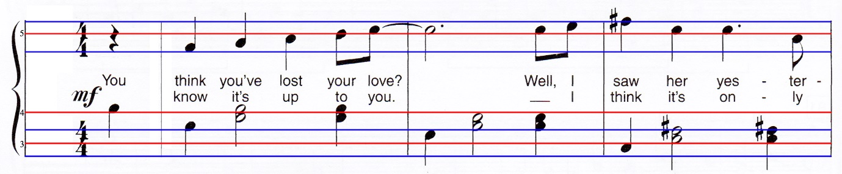
Step 1 complete – WYSIWYP with traditional notes

Step 2 Introduce key signatures.
The key signature would be added back to the beginning of the staff. The sharp and flat symbols for notes belonging to the key signature would disappear. And explicit accidental notation (sharps, flats, and naturals) would remain for notes overriding the key signature. In the simple example shown below, this is a single sharp on F for the G Major key signature.
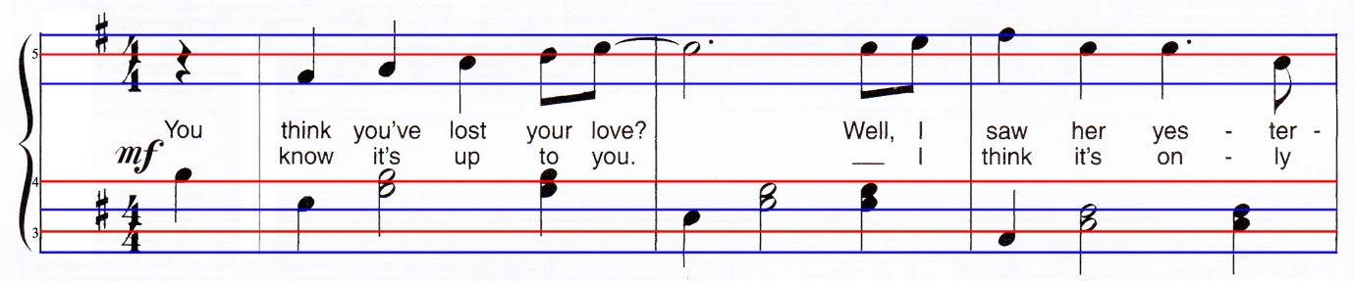
Step 2 – WYSIWYP with traditional notes and key signatures
At this point, the student can practice memorizing key signatures and making real-time playing adjustments that result (changing a natural to a sharp or flat).

Step 3 Convert to the traditional notation staves.
Show both WYSIWYP and traditional staff lines so the student can see how they relate as shown in the following figure. Allow either set of lines to fade until the student can see the relationships between the two. Even after completely removing the WYSIWYP lines, the student may still benefit from them by just visualizing where they fall on the traditional staff. Add in the treble and bass clef symbols.
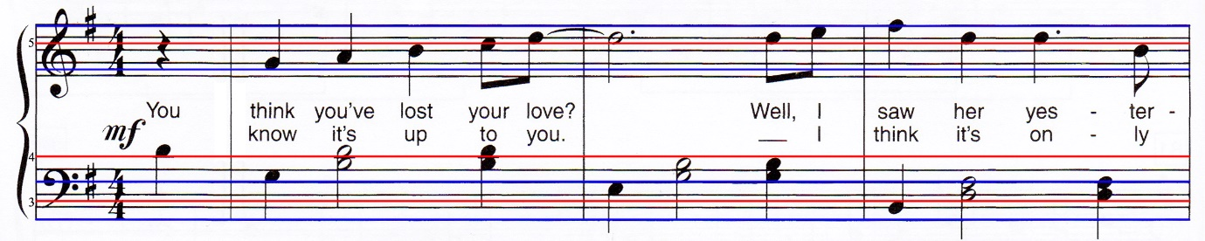
Step 3 Initial - traditional notation with both traditional and WYSIWYP staff lines

Finally, allow the WYSIWYP staff lines (red and blue) to be faded until they disappear and only the traditional black staff lines remain. Now we’re back to the original traditional notation as shown in the following figure.
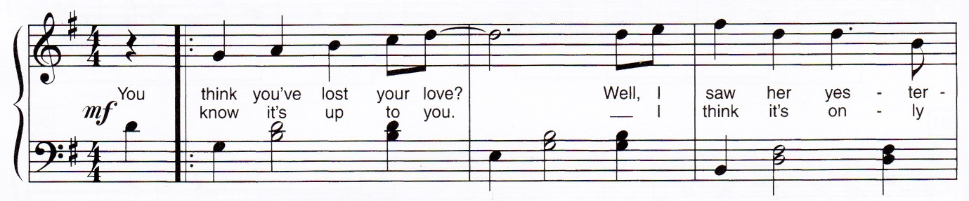
Step 3 Transition complete from WYSIWYP to traditional notation

Conclusion

There has never been, and I expect never will be, a music notation czar who can change standards by simple decree. Notation has evolved by whatever is commonly accepted and actually used by musicians. Today, I believe a revolutionary change to traditional music notation will happen only when a few people adopt it and then it spreads virally on the internet. Eventually, some adherents will become music instructors and begin teaching it to new students, and from there it becomes gospel. But to be successful the app will have to work well, have lots of options, and look cool. Or in the meantime, maybe I'll become czar.

