WYSIWYP - A Simplified Notation for Sheet Music

Introduction

Know anyone who gave up learning to play an instrument because reading sheet music was just too difficult? What if instead of new students of music spending huge amounts of time learning how to read music, they spent that time practicing playing music? What if that made learning to play an instrument fun and not drudgery? What if that meant more people were able to experience the joy of playing music? This is all possible with a new notation that implements a What You See Is What You Play (WYSIWYP) approach.

Background
The modern Western musical notation system evolved primarily through the Middle Ages in a non-scientific fashion. As a result, the system is not consistently logical or intuitive in design for either the staves or the notes themselves. It requires the musician to remember to make real-time playing adjustments to the written notation due to key signatures. It is also difficult to see time relationships among notes across all staves.
Design Goals
The overarching design goal for WYSIWYP is to have notation that is more logical and visually intuitive. This includes redesigning the staves and notes as well as eliminating key and time signatures. It should be noted that this design is driven by a desire to make reading music easier for beginners regardless of age. Therefore, it may not satisfy the goals of musicologists and professional musicians.

Conditions for Success
If the design is successful, beginners will spend less time learning how to read music and more time playing it. Of course, without an inventory of redesigned sheet music, a software application for display devices will have to be developed that will convert traditional notation to this new one. In addition, without instructors or instruction materials, simplified notation will have to catch on in grass roots fashion via the app in the same way that memes spread on social media. Perhaps those who gave up playing music because they just couldn’t learn to read it will find that the app works well for them and their resultant web testimonials will inspire other wannabee musicians to try it. And eventually from these roots may sprout the future instructors that will put simplified notation into the musical mainstream.
What follows is a description of the proposed new notation and some of the features of the app to support it.

Staves and Key Signatures
Problem description
Traditional notation is neither logical nor intuitive in design for either the staves or the notes themselves. The inconsistency of note placement on lines and spaces of the staves exemplifies this.
- A given note in the A-G scale may appear on either a line or a space of the staff depending upon its octave within the staff.
- Assignment of notes to the treble and bass staff lines and spaces are not the same.
- Notes outside the range of the treble and bass staves on register lines are increasingly difficult to read the farther from the staves they are.
As a result, the musician must memorize each note in the same way one memorizes how to type on a computer keyboard. And like the computer keyboard, there is nothing visually logical about the layout other than as the notes go up vertically, so do the note pitches. But learning the mapping to specific notes requires much study and practice.
Staves are visually based on a seven note diatonic octave, but they still must be able to map to the twelve-note chromatic scale. In order to designate the missing five notes, sharps and flats indicate single interval adjustments to the seven natural notes. This would not be so complicated if every written note were explicitly identified with that adjustment. Instead, however, key signatures define implicit adjustment "rules" at the beginning of a musical piece that must be remembered and applied throughout the work's performance. These rules can be overridden with explicit notation, i.e., accidentals, but then there are complicated additional rules for the overrides as well. Thus, identically seen notes can be played in different ways depending on their relative position on a staff. They can also can be played differently depending on how they relate to preceding notes in the same measure with accidentals.
As a result, the musician must not only remember the key signature but must also react on a real-time basis to adjust or not-adjust each note. There is nothing intuitive about this process and it requires much memorization, practice, and concentration.
New Design Approach for Staves and Noteheads
To solve the problems with staves, this design proposes that all octaves look consistent across all staves, that staves can be flexible, and that each notehead explicitly defines whether it’s to be played as a natural, sharp, or flat.

Consistent octaves

Figure 1 shows the representation of a single C Major octave (all naturals) using this octave design approach.
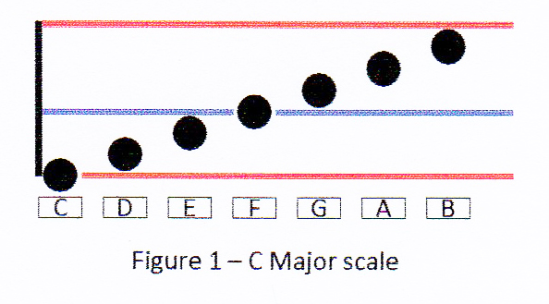
For keyboard instruments, this design takes advantage of the fact that there are two easily identifiable groups of keys on a keyboard because they are separated by gaps in the row of black keys. Thus the octave is subdivided into two subgroups: the "C group" is C-D-E and the "F group" is F-G-A-B. Only two staff lines are then necessary to distinguish these partial-octave groups, one for the C group and one for the F group.
For further clarity, the lines are distinguished from each other by either color or line type. Using color, the C line is red and the F line is blue. Some will find that color can make the two lines visually easier to identify. Not so coincidentally, concert harps have color-coded the C and F strings in just this manner.
Using line types, the C line is a solid black line and the F line is a dashed black line. Using the black lines is more appropriate for musicians with color vision impairments. In addition, when writing music by hand, the black lines will be more convenient. The choice of line format is an example of a display option available to the musician by the application.
Like traditional notation, notes on the octave will overlap vertically by 50% in order to reduce vertical space requirements and also to make the following visualization possible. In the two-line approach with notes overlapping, the C and F lines both have three notes touching them while one note is not touching either line.
Here is how the musician can visualize the seven-note scale from the octave notation:
G touching and sitting on top of the blue line
F covering (and thus touching) the blue line
E touching and below the blue line

D touching and sitting on top of the red line
C covering the red line
B touching and below the red line

A not touching either red or blue lines but floating in between
With this redesigned staff octave, a keyboard musician could mentally visualize red C keys and blue F keys (AKA “minding the gaps”) to have a simple and direct map to the seven diatonic natural notes C through B.
Sharps and flats are explicitly differentiated by the noteheads as follows:
Natural - solid circle
Sharp - solid triangle pointing up like an arrowhead indicating increase by one tone interval (another visual queue is that the top is "sharp")
Flat - solid triangle pointing down like an arrowhead indicating decrease by one tone interval (and the top is "flat")
As shown in Figure 2, a single octave can cover the entire chromatic range of notes either by using all sharps or all flats. (Traditional convention is not to mix sharps and flats in the same work and with this design there is no obvious need to do so either.) The musician has the option of using sharps and flats as they are in the traditional notation for each of the fifteen key signatures requiring them.
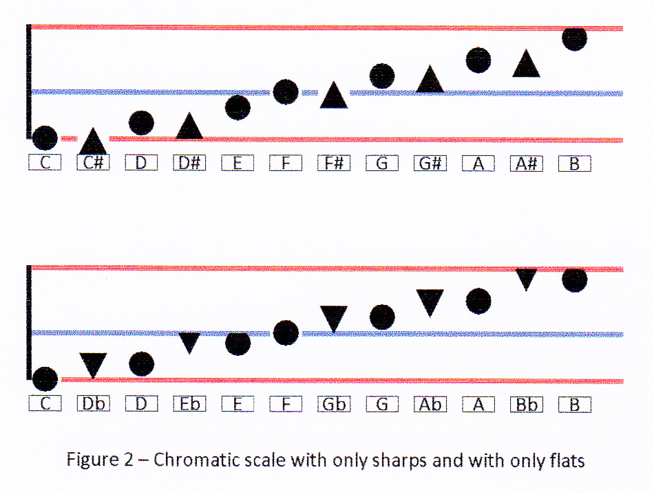
Musicians of keyboard instruments get special benefit with this notation. This is because the circle noteheads map directly to the seven white keys of the octave. An upward pointing triangle on the same position indicates playing the black key to the right of the designated white key, a sharp. While a downward pointing triangle indicates playing the black key to the left, a flat.
In addition, a musician has the option of always using sharps or always using flats regardless of the work's musical key (e.g., B flat Major or A# Major). For example, a piano player could always use sharps so that the only adjustment is the selection of the black key to the right of the white natural key. Others may have a preference for all flats. These are more example options to be provided by the application.
Flexible Staves
Unlike traditional notation staves, in this design staves can expand or contract as needed.
To produce a complete staff, identical octaves are simply stacked up. Each octave is numbered according to its position on the piano keyboard. Thus octave number four starts with middle C. In this way, the piano keyboard can be visualized not as a continuum of eighty-eight keys but as seven mini-keyboards, each comprised of a twelve-key octaves (plus four "extra" keys at the extreme ends of the keyboard). Therefore, to learn to play every white key on the keyboard, a piano player need only learn the seven-note mapping of the octave and how to locate the numbered mini-keyboard. In playing, the adjustment from white to adjacent black key is explicitly specified by the notehead as previously described.
The nearly equivalent note range of the traditional treble and bass staves can be reproduced in the new design as shown in Figure 3. Numbers to the left of the C lines indicate their location on the piano keyboard.
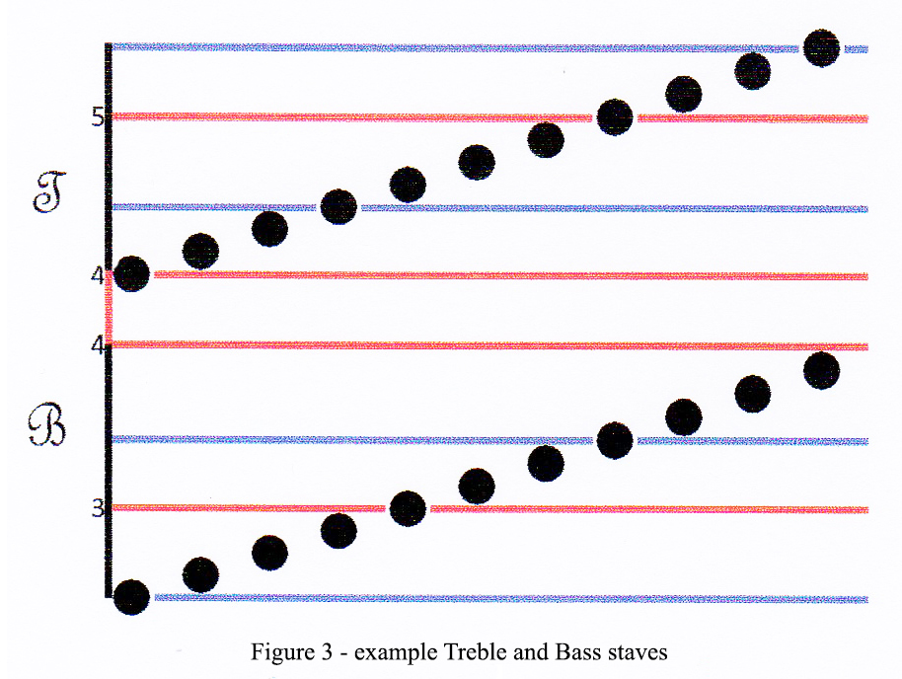
As with traditional notation, these two staves can be separated by extra space to make them visually easier to differentiate and to add any other additional notation (e.g., slurs and dynamics) and lyrics. But this is not required. In this example, the lines representing C4 are connected between the higher and lower staves to further emphasize that they represent the same note. It is also possible for the treble and bass staves to overlap such that a common range of notes is duplicated on both.
Ledger lines are not used but instead a staff can be flexible in tonal range. A staff can be created with any number of octaves and partial octaves, where partial octaves are the C and F groups. With the two line per octave approach, even when stacking up several octaves to create a staff, the look is very "clean" and not overwhelming in vertical space or number of lines.
The example in Figure 3 does not include other notational elements for a complete staff in the new design. These are described in the next section. Note that the treble and bass clef symbols are just samples and can be customizable with the application by the musician (or not used at all). In fact, the musician can define any number of unique staves and name them according to their use (and optionally add clefs).
An alternative to stacking up octaves to an extreme height or depth is to simply change the octave number as shown in the figure 4. This effect is similar to scrolling on a display device where the content moves up and down in a fixed visual "window". Staves are also flexible on the horizontal time axis so that works (or parts of works) with many notes per measure can be spread out in order to be viewed with ease.
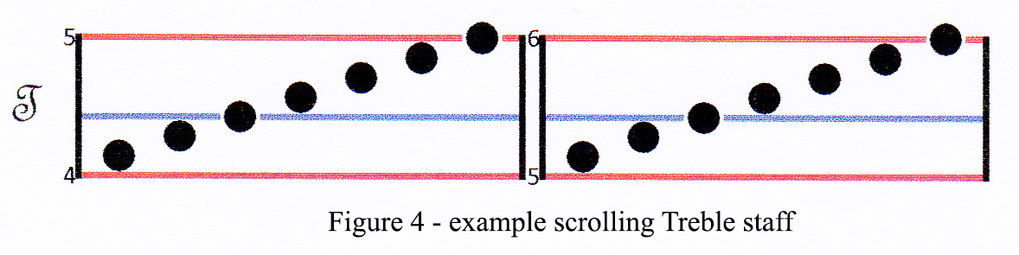

Note Durations and Beat

Problem Description

Notation for duration in the traditional system is complex and non-intuitive. For example, all of the following symbols must be taken into consideration in order to calculate note duration:
  - noteheads
  - stems
  - flags
  - beams
  - dots and articulations
  - ties
  - tuplets
There is also another parallel range of symbols just for rest durations. Furthermore, musicians must coordinate notes between Treble and Bass wherein:
- The start and end of notes may not be aligned.
- The duration of concurrent notes may be different.
With traditional notation, duration is not intuitive nor is how notes relate to each other in time. And finally, there is no clear indication of how notes relate to the beat of the work.

New Design Approach for Note Durations and Beat
To remedy these problems, the horizontal axis of the staves is converted to a true timeline. Noteheads are placed so as to visually indicate the start and duration of the note on the timeline as well their relationships to other notes on all staves. This basic concept can be seen in on-screen TV grids wherein channels are shown vertically and programs are displayed as "stripes" on a horizontal timeline. It’s clear how long a program lasts and how it relates to other programs (serially, concurrent, overlapping).
Figure 5 shows an example of WYSIWYP notation compared to traditional notation. The WYSIWYP segment illustrates some examples of various note and rest durations, chords, and treble/bass note relationships. The start of the note, that is, when the tone actually begins, is represented by the location of the notehead on the time axis of the staff. Unless there is a leading rest (as in this example), the first notehead appears at the extreme left of the first measure. Behind the notehead is a horizontal stripe that continues until the end of the duration of the note. Often this will be the start of another note. A section on the timeline without any stripes indicates a rest. Thus, no explicit symbols are required for rests.
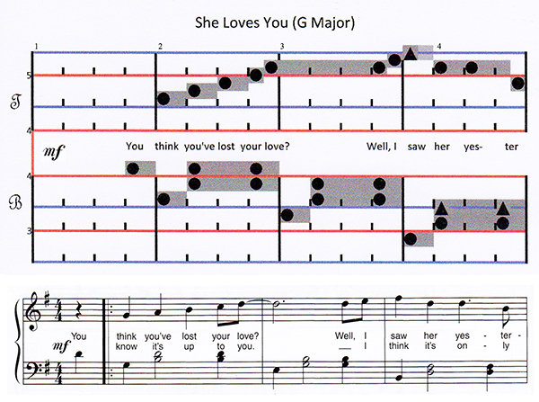
Figure 5 – Example tune in WYSIWYP notation and in traditional notation

Other "auxiliary" notation affecting note duration is no longer needed as they are visually incorporated into a consolidated duration. Thus, there is no need for ties that are necessary to create notes not of power-of-two fractions of a whole note, e.g., tying a quarter note to an eighth note to create a "three-eighths" note. Notes tied together in the traditional notation are presented in the proposed design as a single note of the appropriate length on the horizontal time axis. Likewise, there is no need for dots that add or subtract 50% of a note's duration. These too are consolidated in order to show total tone durations.
As with traditional notation, measures are indicated by vertical bars that span all staves vertically. Numbers above the staff at the start of each measure are the sequential measure numbers.
Most notably, there are also equally spaced hash marks within the measures that indicate the beats. Notes and rests are then aligned with respect to the beats. In figure 5 there are four beats to the measure. Notes may span not only beat boundaries but also measure boundaries.
This graphical approach allows the musician to see directly the length of a note as well as its relationships to other notes on all staves. There is no need for the traditional time signature (e.g., 4/4). The number of beats per measure is clearly indicated by the beat hash marks. Notes and their durations to be played are shown explicitly within each beat. Thus, there is no need for the concept of whole, half, quarter, etc. notes (and likewise for rests). For terminology sake, note durations can be expressed in relation to the beat, e.g., half-beat, full-beat, double-beat, three-eighths-beat, and so forth). The notes to be played within a given beat, or across multiple beats, are visually clear and their interpretation is intuitive. Musician reaction time is not impaired due to any intermediate analysis of multiple symbols (noteheads, staves, flags, dots, ties, etc.).

When composing by hand, the stripes may not be conveniently drawn, so substituting a simple horizontal line can be substituted. To make it more clear where the line ends, an “X” symbol could be placed at the end of the line.

Traditional Notation not Affected
All functionality provided by traditional notation continues to be available either in a redesigned or original form. Thus, elements of the traditional notation that are not subsumed by this simplified approach are retained and presented in the same fashion. These include but are not limited to:
- Slurs
- Dynamics
- Tempo marks
- Metronome marks (bpm)
- Instrument-specific notation

Conclusion

Throughout this design, the approach has been to make the implementation to be as visual as possible. This is to avoid intermediate "translations" or "computations" by the musician in order to arrive at a final note playing destination. This makes the process of reading music as simple and direct and as intuitive as possible. Here are some examples of how the design simplifies the reading of music notation.
- Because octaves are consistent, the musician needs to learn only one mapping to the seven diatonic scale degrees of an octave.
- Because noteheads explicitly define naturals, sharps, and flats, it is easy to map to the remaining five chromatic scale degrees by a simple real-time playing adjustment.
- Because noteheads are explicit there is no need to memorize a piece's key signature in order to make commensurate real-time playing adjustments.
- Because note duration is expressed visually and intuitively, the musician does not have to learn a host of notation symbols and key signature rules and exceptions to the rules. Furthermore, no notation at all is needed for rests.
- Because notes are placed on a timeline, it is visually clear how notes relate to each other on all staves as well as to the beat. Piano players can easily see how notes relate across staves.
For all of the above reasons, one could describe the visual results of this approach as What You See Is What You Play, or WYSIWYP.
It should be re-emphasized that this design is aimed at new students of music in order to make their paths to playing music easier and less stressful. It is not the intent to convert musicians already trained in the traditional system to a different one. After learning the joys of playing music, it would be hoped and expected that many students would indeed want to become more "serious" and would want, and need, to learn to read traditional notation. For this reason, some design choices were made to avoid unnecessarily veering too far off course from traditional notation.
If this approach or any other were to catch on in a "grass roots" combination of app use and new student instruction, then perhaps a new universally accepted design standard will eventually evolve.

